|  |  |
| --- | --- |
| IDEM LOGO 2006.bmp | **Fish Community Field Collection Procedures**  B-009-OWQ-WAP-XXX-23-T-R1  **Technical Standard Operating Procedure (TSOP)**  **Office:** Office of Water Quality  **Branch:** Watershed Assessment and Planning Branch  **Section:** All  **Last Revised: March 21, 2023**  **Revision Cycle:** Every 4 years  **Originally Effective:** January 31, 2018 |

# Purpose

This technical standard operating procedure (TSOP) describes the methods for collecting a representative fish community sample consistently in the field. Specifically, this TSOP covers the method for laying out the sample reach, factors to consider when electrofishing (type of equipment, direction of sampling, number of netters), collecting data for fish captured, sample preservation, and delivery. Fish community sampling will be performed using various standardized electrofishing methodologies depending on stream size and site accessibility. The actual operation of electrofishing equipment will be presented in another TSOP for fish community and fish tissue specimen collections.

Fish community samples are collected during low flow (June through mid-October) if the flow is not dangerous for staff to enter the stream (e.g., water levels at or below median base flow) and barring any hazardous weather conditions (e.g., thunderstorms or heavy rain in the vicinity), or unexpected physical barriers to accessing the site. The crew chief makes the final determination as to whether a stream is safe to enter. Even if the weather conditions and stream flow are safe, sample collection for fish community may be postponed at a particular site if there are signs of recent high water (e.g., muddy vegetation and debris in canopy covering stream, or water level in grasses/vegetation that looks to be dry normally).

# Scope

This TSOP applies to agency staff in the Office of Water Quality (OWQ) Watershed Assessment and Planning Branch (WAPB) who are responsible for collecting representative fish community samples from streams and rivers in Indiana.

Kevin Gaston, Senior Environmental Manager, served as the primary author of this TSOP.

# Authorizing Signatures

I approve and authorize this technical standard operating procedure:

____________________________________________ ________________

Kayla Werbianskyj, Environmental Manager Date

Office of Water Quality, Targeted Monitoring Section

____________________________________________ ________________

Cameron Yeakle, Environmental Manager Date

Office of Water Quality, Targeted Monitoring Section

____________________________________________ ________________

Michael Schneider, Environmental Manager Date

Office of Water Quality, Probabilistic Monitoring Section

____________________________________________ ________________

Stacey Sobat, Section Chief Date

Office of Water Quality, Probabilistic Monitoring Section

____________________________________________ ________________

Kristen Arnold, Branch Chief Date

Office of Water Quality, Watershed Assessment and Planning Branch

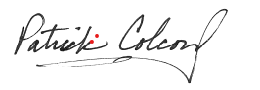This technical standard operating procedure is consistent with agency requirements.

4/25/23

____________________________________________ ________________

Quality Assurance Staff Date

Office of Program Support

# Table of Contents

Purpose 1

Scope 1

Authorizing Signatures 2

Table of Contents 3

1.0. Overview Flowchart 4

2.0. Procedure 5

2.1. Procedural Flowchart 5

2.2. Procedural Steps 5

2.3. Related Technical Issues 10

3.0. Roles 15

4.0. Required Forms, Equipment, or Software List 16

5.0. Records Management 16

6.0. Definitions 17

7.0. Quality Assurance and Quality Control 20

8.0. References 21

9.0. Appendices 22

# Overview Flowchart

**

# Procedure

## Procedural Flowchart



## Procedural Steps

* + 1. Using a hand-held global positioning system (GPS) unit (see TSOP for Global Positioning System (GPS) Data Creation IDEM 2022), Indiana Gazetteer, or site-specific maps (Appendix 1), the crew drives to parking location as described on the Site Reconnaissance Form (Appendix 2).
    2. The crew chief affixes the site folder to the clipboard, which includes the site maps, Site Reconnaissance Form (Appendix 2), Photographic Image Chain of Custody (Appendix 3), Stream Sampling Field Data Sheet (Appendix 4), Fish Collection Data Sheet (Appendix 5), Qualitative Habitat Evaluation Index (QHEI) Form (Appendix 6), and OWQ Chain of Custody (Appendix 7). All forms should be completed using a pencil or pen with water resistant ink.
    3. Using the Fish Community Sampling Checklist (Appendix 8), the crew chief checks to make sure that all the equipment necessary to conduct fish community sampling is present and secured for transportation to the sampling site.
    4. Using a hand-held GPS unit and the Site Reconnaissance Form, the crew travels to the “x-point” and determines if the site can be sampled. In order to be sampled, water must be present in 50% of the stream reach, defined as 15 times the average wetted width of the stream. If the site can be sampled, proceed to Step 6. If the site cannot be sampled, proceed to Step 5.
    5. If the site cannot be sampled, a crew member takes a photograph of the site illustrating why the site was rejected and records information about the photograph in the “Special Notes” section on the Stream Sampling Field Data Sheet. The photograph is labeled with a three-digit U.S. EPA site identification number, the reason for rejection, initials of the photographer, and date as MMDDYY (i.e., 001 logjam KAG 061523) and stored on the Shared Drive (S:) in the respective project. The crew chief completes the Stream Sampling Field Data Sheet by entering the date, time, and checking the appropriate response for “Sample Taken.” If checking “No; Other”, explain in the “Special Notes” why the site was not sampled. The crew returns to the vehicle and, if time allows, travels to the next site and repeats the process, starting at Step 1.
    6. If the site can be sampled, a crew member uses a camera to take an upstream and downstream photograph, noting the GPS position from which those photos were taken, while other crew members complete the collection of in-situ water chemistry measurements and the Stream Sampling Field Data Sheet. Abnormalities at the site that may be affecting water quality such as algal blooms, dead fish, or modifications to the bank or stream are photographed and noted in the “Special Notes.” The photograph is labeled with a three-digit U.S. EPA site identification number the direction of flow, upstream (US) or downstream (DS); initials of the photographer; and date as MMDDYY (i.e., 001 US KAG 061523) and stored on the Shared Drive (S:) in the respective project folder.
    7. A crew member measures the average wetted stream width (not the channel) at an area with the most representative stream width near the “x-point”. Measurements are to the nearest meter using a rangefinder and are recorded in meters (m) on the Fish Collection Data Sheet.
    8. The crew chief lays out the sample reach with a length of 15 times (15x) the average wetted stream width with a minimum distance of 50m and maximum distance of 500m.
    9. Using a rangefinder, the crew chief determines the location of half the sampling reach upstream and downstream from the “x-point”.
    10. The crew conducts a brief reconnaissance of the sample reach to identify any obstacles, hazards, or nonwadeable pools. While conducting reconnaissance, crew members make sure not to disturb the sample reach. If any of these are present, the sample reach may need to be adjusted (see 2.3 E. Troubleshooting), or a canoe or boat may need to be utilized for sampling.
    11. Based on reconnaissance of the sample reach, the crew chief chooses the appropriate sampling gear type (Appendix 9). The crew travels to the start of the sample reach (upstream or downstream depending on equipment type).
    12. The crew conducts electrofishing of the entire reach. Factors to consider when electrofishing (i.e., number of netters, time of year for sampling, etc.) are explained in Appendix 9. Fish will be collected using dip nets with fiberglass handles and netting of 1/8-inch bag mesh. If a large number of fish are collected, the crew conducting the sampling may need to break down the sampling reach into segments. Should this occur, the fish collected from each segment will either need to be transferred to a live well that allows water to circulate/pass through or the fish will need to be processed and placed within a holding pen/live well to avoid another fish collection.
    13. Once the reach has been sampled, crew members return to the staging area to identify, and sort collected fish by species into individual buckets and/or netted baskets. Young-of-the year fish less than 20 millimeters (mm) total length are not retained in the assemblage sample. If the site being sampled is large and additional staff is present, the samples can be processed simultaneously while sampling is being completed. During simultaneous sampling, any fish being processed are placed within a holding pen/live well to allow the fish to recover and to avoid fish from being collected an additional time.
    14. While crew members are sorting fish, another crew member completes the Fish Collection Data Sheet with Event ID/Sample Number (YY and last 3 digits of the EPA site identifier (i.e., 23001/AB12345), equipment, voltage, time fished in seconds, distance fished (m), maximum and average depth (m), indicate Yes (Y) or No (N) to Bridge in reach, and indicate Yes (Y) or No (N) to Is reach representative. If no, then explain why the reach is not representative (i.e., beaver dam has blocked stream reach).
    15. Prior to sampling, 10% of all sites sampled in a project are randomly selected to serve as revisit sites. Prior to processing fish specimens and completion of the Fish Collection Data Sheet at revisit sites, one to two individuals per species are chosen to serve as voucher specimens. Vouchers are preserved in 3.7% formaldehyde solution. If small enough, place the voucher into a 2000 milliliter (mL) jar. If not small enough, digital images are taken and recorded on the Fish Collection Data Sheet. For each fish taxonomist (generally the crew chief), a complete set of fish vouchers or digital images are retained for each new or different species encountered during the summer sampling season. Digital images are stored on the Shared Drive (S:). Record the number of voucher jars on the Fish Collection Data Sheet.
    16. Fish specimens are also preserved or photographed if they cannot be positively identified in the field. Individuals that appear to be hybrids or have unusual anomalies, as well as dead specimens that are taxonomically valuable for un-described taxa (i.e., Red Shiner or Jade Darter), life history studies, or research projects. Fish kept for this reason are kept separate from the voucher specimens. The number of unknown (i.e., jars with unprocessed fish) and voucher (i.e., jars with processed fish) jars is recorded on the Fish Collection Data Sheet (Appendix 5 and 6). If digital images are taken, record the photography number(s) for each species on the Fish Collection Data Sheet.
    17. The crew’s fish taxonomist will look over the species prior to crew members recording data for non-preserved fish on the Fish Collection Data Sheet consisting of the following:

1. Number of individuals
2. Minimum and maximum total length (mm)
3. Mass weight in grams (g)
4. Number of individuals with deformities, eroded fins, lesions, tumors, and other anomalies (DELTs).

[State Endangered/Special Concern fish species](http://www.in.gov/dnr/fishwild/files/fw-Endangered_Species_List.pdf) should be processed and released as soon as possible. Data will be recorded for preserved fish specimens following taxonomic identification in the laboratory.

* + 1. Once the data have been recorded, specimens are released within the sampling reach, if possible.
    2. Before leaving the site and heading back to the vehicle, the crew chief completes the Qualitative Habitat Evaluation Index (QHEI). Once all the sampling is completed at the shoreline, the crew packs up all the equipment and travels back to the vehicle.
    3. Upon return to the vehicle, a crew member will write the event ID, sample number, date, waterbody, and initials in pen or black Sharpie on the label tape on the lid of the 2000 mL voucher, any unknown jar(s), and in pencil on the Rite-in-the-Rain label stored inside the jar with the fish specimens. The jars are stored upright in a tote for transportation to the laboratory unless lamprey are present. Jars containing lamprey are stored on their side to keep the lamprey straight during preservation.
    4. Crew members will decontaminate field equipment using a 3% bleach solution or Virkon following each sampling run or between sampling sites any time:

1. Equipment is being used in a different 8-digit Hydrologic Unit Code (HUC).

2. Viruses (e.g., viral hemorrhagic septicemia (VHS)) have been detected in the area.

Crew members will decontaminate field equipment using only a 3% bleach solution following each sampling run or between sampling sites any time when entering Indiana Department of Natural Resources interested lands or National Parks.

If the equipment is allowed to sit and dry for five or more days, decontamination is not necessary.

* + 1. Prior to leaving the sampling site, the crew chief ensures the OWQ Biological Samples Field Chain of Custody Form (Appendix 7), and Field Notebook (example Appendix 10) are completed.
    2. If time allows, the crew starts the process over at Step 1.
    3. If time does not allow for sampling another site, the crew travels back to the office or laboratory.
    4. Upon return to the office/laboratory, the crew chief checks in the voucher and unknown jars with a laboratory supervisor using the OWQ Chain of Custody Form (Appendix 8). Fish specimens must sit in the 3.7% formaldehyde solution for a minimum of two weeks prior to removal and identification, for proper fixation of tissue.
    5. It is a good practice to transfer photos from the camera to the storage folder as soon as possible after returning from the field. It is also best to record any accompanying explanatory information about the photos at that time. This helps ensure photo file folders are adequately organized and less subject to data loss. It also is recommended that photos be stored using adequate/as high as practicable digital resolution.

## Related Technical Issues

1. Health and Safety Warnings
2. Per recommendation of the IDEM Health and Safety Director, when heat index temperatures reach 100oF, field work should be reduced to a 50% work and 50% rest schedule (IDEM 2010b).
3. When heat index temperatures above 105oF require suspension of field work activities, until heat index temperatures decrease below 105oF (IDEM 2010b).
4. Field personnel will follow policies and procedures established in the IDEM Hazard Communication (HazCom) Plan (IDEM 2019) and “Office of Water Quality Watershed Assessment and Planning Branch Laboratory Safety Plan” (IDEM 2021).
5. Sampling on surface waters requires safety consciousness of staff members and the use of specialized equipment; thus, staff will comply with the IDEM Personal Protective Equipment (PPE) Policy (IDEM 2008). If an injury or illness arises in the field, staff will follow the IDEM Injury and/or Illness Resulting from Occupational Exposure Policy (IDEM 2016).
6. Operating in and around waterbodies carries inherent risks of drowning; thus, personnel involved in sample collection will wear appropriate clothing and PPE when operating boats or sampling in deep water or swift currents. When work is being done in boats on boundary waters (Indiana Code (IC) 14-8-2-27) or between sunset and sunrise on any waters of the state, all personnel in the watercraft must wear a high intensity whistle and Safety of Life at Sea (SOLAS) certified strobe light. According to the memorandum "Use of Personal Flotation Devices (PFDs) by Branch Personnel" (IDEM 2000), staff must wear U.S. Coast Guard approved Type I, II, or III PFDs whenever:
   1. The planned work requires staff to enter the water and the maximum water depth at any place at the work site is over the knee (note that this depth depends on the employee, but it will usually be between 12 to 20 inches or 300 to 500 mm).
   2. The employee is in a watercraft of any kind that is being launched, is in the water, or is being retrieved from the water.
   3. The employee must work from structures that do not possess guard rails and are over or alongside water where the water depth is, or could reasonably be expected to be, 3 feet or more.
7. In addition, when work is being done in boats on boundary waters as defined by Indiana Code (IC) 14-8-2-27 or between sunset and sunrise on any waters of the state, all personnel in the watercraft must wear a high intensity whistle and Safety of Life at Sea (SOLAS) certified strobe light.
8. Safety issues are the responsibility of all crew members; however, any questions in the field should be directed to the crew chief. The crew chief is responsible for the completion of all work listed in the TSOP, the health and safety aspects of the sampling event, and successful interactions with landowners and members of the public.
9. Location of safety equipment: The Safety Data Sheets (SDS) for formalin and Virkon are kept by the crew chief with the Scientific Collector License while in the field. The SDS are also kept in a binder at the Shadeland labs and warehouse where the substances are housed as well as online in the MSDS e-binder (https://chemmanagement.ehs.com/9/201afa5a-535e-4bbd-afec-82f4bc001fa1/ebinder). An eye wash kit and first aid kit are kept in the vehicle.
10. Electrofishing shock hazards and safety:
    1. Never electrofish alone or if a crew member feels exhausted.
    2. Do not electrofish under inclement weather conditions and do not operate the electrofishing system close to a shoreline where people or animals are located.
    3. Keep and maintain an Automatic External Defibrillator (AED) in a dry bag at the site when electrofishing as well as a cellular phone.
    4. All crew members must wear protective non-breathable waders, hip boots, or calf boots and high voltage lineman gloves when conducting electrofishing activities. Waders, boots, and gloves protect crew members from the electrical current applied to the water. Waders provide additional protection against thorns, nettles, and poison ivy that may be encountered during the walk to the sampling site. Abrasions may result from in stream boulders and logs and from contaminants in the water.
    5. Dip nets used for electrofishing have handles that are made only of non-conducting material such as fiberglass or epoxiglass.
    6. Make equipment and electrical line checks for condition, integrity, and grounding before every electrofishing effort.
    7. All team members should constantly be aware of all the other team member’s positions and know where all power switches are located on the electrofishing system to shut it down should someone fall in.
    8. If possible, crew members should wear polarized eye protection when conducting field sampling activities which allow the wearer to view into the water column without surface glare
    9. If possible, crew members should wear polarized eye protection to protect against objects poking or splashing into your eyes as well as eye strain.
11. Formalin hazards and safety:
    1. Review the appropriate SDS before working with formalin and use appropriate PPE.
    2. Flammable liquid and vapor
    3. Toxic if swallowed or inhaled
    4. Toxic in contact with skin
    5. Causes severe skin burns and eye damage
    6. May cause drowsiness or dizziness
    7. Causes damage to organs
    8. Toxic to aquatic organisms
    9. When preserving samples in the field, staff are encouraged to position themselves upwind of the sample and formalin container. In the laboratory, staff should place the item containing the preservative in the fume hood.
12. Virkon S hazards and safety:
    1. Review the appropriate SDS before working with Virkon S and use appropriate PPE.
    2. Moderate skin irritation
    3. Risk of serious damage to eyes
    4. Respiratory tract irritant
    5. Prevent Virkon from entering sewers, waterways, or low areas as materials can be toxic to aquatic organisms
    6. Ensure adequate ventilation when mixing and avoid eye and skin contact.
13. Bleach hazards and safety:
    1. Review the appropriate SDS before working with Bleach and use appropriate PPE.
    2. 1:32 dilution (bleach:water) for 3% solution using 6% concentration of household bleach.
    3. Vapor may cause severe irritation or damage to eyes and skin.
    4. Harmful if swallowed.
    5. Corrodes metals.
    6. Will fade colors and break down cloth fibers.
    7. If in an opaque container, diluted bleach will last 1 month.
    8. If exposed to sunlight or air, it will only las 5 days.
    9. Keep out of lakes, streams, and ponds; stand at least 50 meters from any natural water source.
14. Cautions
15. When traveling to the “x-point,” follow instructions on the site reconnaissance as hazards may be present on path to a stream. While laying out the sampling reach make sure to keep all rangefinders clean and dry as moisture will affect the equipment.
16. If a site has an unknown or voucher jar, make sure enough formalin is in the jar to cover the fish. Proper fixation will not occur if there is not enough formalin in the jar resulting in decomposition of tissue. If a lamprey is within one of the jars, place the jar on its side to prevent the lamprey from curling up inside the jar. This can make identification difficult.
17. While sampling, netters need to be aware of their surroundings where equipment (e.g., float lines, nets, boats, boat motors, etc.) could be caught up on an object (e.g., log, boulder, etc.) Some objects in the water may not be visible to the boat driver or individual with the electrofishing equipment.
18. When using Virkon S or a 3% bleach solution, avoid exposing the chemical to excessive heat, direct sunlight, and moisture. This could result in the chemical becoming instable and cause hazardous decomposition, which produces sulfur dioxide and chlorine.
19. Interferences
20. Heavy rains leading to overland runoff entering streams can create dangerous sampling conditions causing rising stream levels and increased turbidity. A stream should not be sampled during a high flow event. High flow events can lead to non-representative samples due to increase turbidity which reduces the netters’ ability to see the fish. When walking to a site make sure to avoid walking through the water as much as possible to avoid disturbing the reach prior to sampling. Disturbing the reach can cause the sample to not be representative. The crew chief will use best professional judgement in determining whether a stream should be sampled by looking at rainfall in the area (past and forecasted) along with nearby stream gauging stations.
21. Calibration
22. Electrofishing equipment required for the collection of fish is used and maintained according to manufacturer’s specifications and evaluated for performance prior to each sampling season. Nets are checked for holes and repaired prior to use. Scales used for weighing fish are calibrated annually. Site revisits will be conducted at ten percent of the sites sampled. The revisit wetted width should be within 75% of the original width. During these revisits a different staff member will run the electrofishing equipment. From these revisits, relative percent difference (RPD) is calculated to determine if sampling effort between staff is comparable.
23. Troubleshooting
24. When laying out the reach, make sure to scan the whole reach for possible hazards such as deep pools, large boulders, large metal objects (e.g., cars, rebar, home appliances, signposts, etc.). If you encounter any of these objects that may hinder your sampling, move the reach either upstream or downstream, and note moving the reach in the Comments on the Fish Collection Data Sheet. If there is a dam, impoundment, physical barrier, or a stream order change along the survey reach, end the sample reach at the feature. Make up the loss of stream length by adding length to the other end of the reach by “sliding” the reach. Do not slide the reach to avoid bridges, riprap, small flow control structures, culverts and the like. The “x-point” can serve as the starting point or end point of the reach to be electrofished, but the “x-point” must remain within the reach.
25. If equipment failure or malfunction occurs, a replicate sample will be collected at least two weeks after the original sample was collected. This allows the stream to recover from the previous sampling event. Replicate samples receive a separate sample number, and the same Event ID with a “.25” at the end (e.g., 23001.25).

# Roles

1. Responsibilities

A. Crew chief

1. Health and safety of self and crew (IDEM 2006, IDEM 2016)
2. Preparation for sample collection
3. Laying out the fish community sample reach
4. Operation of electrofishing equipment
5. Collecting data for fish captured
6. Specimen preservation and vouchers
7. Cleanup, paperwork, and sample delivery

B. Field crew

1. Health and safety of self and crew chief (IDEM 2006, IDEM 2016)
2. Preparation for sample collection
3. Laying out the fish community sample reach
4. Operation of electrofishing equipment
5. Collecting data for fish captured
6. Specimen preservation and vouchers
7. Cleanup, paperwork, and sample delivery
8. Training requirements

A. Health and Safety training: Basic First Aid, CPR, Annual Safety Training (minimum of 4 hours) (IDEM 2010a), and Policies and procedures established in the Hazardous Communication Plan Supplement (IDEM 1997)

1. Crew chief
2. Field crew

B. Principles of electrofishing

1. Crew chief
2. Field crew

C. Preparation for sample collection

1. Crew chief
2. Field crew

D. Laying out the fish community sample reach

1. Crew chief
2. Field crew

E. Collecting data for fish captured

1. Crew chief
2. Field crew

F. Specimen preservation and vouchers

1. Crew chief
2. Field crew

G. Cleanup, paperwork, and sample delivery

1. Crew chief
2. Field crew

# Required Forms, Equipment, or Software List

1. Forms

A. Site Reconnaissance Form

B. Photographic Image Chain of Custody

C. Stream Sampling Field Data Sheet

D. Fish Collection Data Sheet

E. Qualitative Habitat Evaluation Index

F. OWQ Chain of Custody

G. Safety Data Sheets (SDS)

1. Equipment

See Appendix 8 for complete list.

1. Software

A. Assessment Information Management System (AIMS) database

# Records Management

1. All the voucher fish specimen photos will be grouped by fish taxonomist by year and saved to the WAPB Shared Drive. All unknown fish specimen photos will be grouped by project and saved to the WAPB Shared Drive.
2. The Stream Sampling Field Data Sheet, Fish Collection Data Sheet, and Qualitative Habitat Evaluation Index are entered into AIMS by Watershed Assessment and Planning Branch staff and checked twice for data entry errors. Forms are kept in the site folder and stored in a file cabinet in the Watershed Assessment and Planning Branch office area at the IDEM Shadeland office until uploaded into IDEM Virtual File Cabinet (VFC).
3. Following aquatic life use assessments for the Integrated Report, original copies of the forms (e.g., Stream Sampling Field Data Sheet, Fish Collection Data Sheet, QHEI Sheet, etc.) are scanned and stored as attachments in AIMS at the Project Level. Once scanned, the file attached in AIMS is checked for completeness and clarity before the original copies are recycled.

# Definitions

1. “Agency staff” – Any employee or representative of the Indiana Department of Environmental Management (IDEM) including regular employees, temporary employees, contractors, and interns.
2. Assessment Information Management System database (AIMS database)” – IDEM database containing information related to water chemistry, aquatic habitat, macroinvertebrate, fish, and algae communities, fish tissue analyses, sediments, and *E. coli* bacteria data collected by agency staff from watershed sampling events.
3. “Best Professional Judgment” – Applying knowledge, skills, and experience, in a way that is informed by professional standards, laws, and ethical principles, to develop an opinion or decision about what should be done to best complete the task.
4. “Chain of custody (COC)” – The records documenting the possession of the samples from the time they are obtained until they are disposed of or shipped off-site. (Appendix 7).
5. “Crew chief” – The agency staff person who leads a field crew when conducting field sampling activities.
6. “Environmental Protection Agency (EPA) site ID” – The identification number generated by the U.S. EPA Pacific Ecological Systems Division Laboratory in Corvallis, Oregon, given to the 100 random probabilistic sites drawn yearly. i.e., INRB16-001.
7. “Field crew” – The team of agency staff who conducts field sampling activities. Field crews must contain at least one full-time agency staff member from the Probabilistic or Targeted Monitoring Sections in the crew chief position and one or more full-time IDEM staff of Governor’s summer interns or compensated interns.
8. “Gazetteer” – A reference book listing cities, towns, rivers, mountains, and other geographic features along with the exact location of these features.
9. “Glide” – An area common to most modified stream channels that do not have distinguishable pool, run, riffle habitats; the current and flow is similar to that of a canal; the water surface gradient is nearly zero.
10. “Governor’s summer intern” – An intern selected and compensated under the Governor’s Public Service Internship program; a program created to introduce college students to the operations and officials of state government. Governor’s Summer Interns are compensated, intermittent employees usually working full-time hours from May to September.
11. “Indiana Department of Environmental Management (IDEM)” – An agency of Indiana State Government whose mission is to implement federal and state regulations to protect human health and the environment while allowing the environmentally sound operations of industrial, agricultural, commercial, and government activities vital to a prosperous economy.
12. “Office of Water Quality (OWQ)” – The Office of Water Quality within the IDEM.
13. “Quality assurance (QA)” – An integrated system of management activities involving planning, implementation, documentation, assessment, reporting, and quality improvement to ensure that a process, item, or service is of the type and quality needed and expected by the client.
14. “Quality control (QC)” – The overall system of technical activities that measures the attributes and performance of a process, item, or service against defined standards to verify that they meet the stated requirements established by the customer; operational techniques and activities that are used to fulfill requirements for quality. In other words, QC involves measuring the "thing produced" against a standard to ensure it is a quality product that meets the identified need.
15. “Reconnaissance” – A preliminary survey to gain information. Obtaining information about a site through visual observations and investigating routes to safely access the site, as well as gathering property owner information and access permission.
16. “Replicate site” – Sampling site chosen to sample at least two weeks after the initial sampling event due to the initial sample not being representative due to environmental factors (e.g., turbidity) or equipment malfunction.
17. “Revisit site” – Sampling site randomly chosen to sample at least two weeks after the initial sampling event to measure precision for fish assemblage samples. During the revisit, the sampling reach and type of equipment (backpack, boat, etc.) should be the same; however, the equipment and crew members should be different since the intent is to measure the precision (or reproducibility) of the sampling methodology to produce a similar Index of Biotic Integrity (IBI) score.
18. “Riffle” – The shallow parts of the stream where water flows swiftly over completely or partially submerged pebble to boulder sized rocks to produce surface agitation.
19. “Run” – Areas of the stream that have a rapid nonturbulent flow; runs are deeper than riffles with a faster current velocity than pools and are generally located downstream from riffles where the stream narrows; the stream bed is often flat beneath a run and the water surface is not visibly broken (Ohio EPA 2006).
20. “Safety Data Sheet (SDS)” – A sheet containing data regarding the properties of a particular substance or product. It is intended to provide workers and emergency personnel with procedures for handling or working with that substance or product in a safe manner.
21. “Sample number” – A number assigned to each individual watershed sampling event conducted by IDEM staff. This number is used to identify the sampling event in the AIMS database. This number is automatically generated in the Assessment Information Management System (AIMS) database.
22. “Site folder” – A folder for a specific site that contains all pertinent paperwork to do with the site. Site reconnaissance forms, all field data sheets including those for water chemistry, algal biomass, fish community, macroinvertebrate community, chain of custody forms, etc. are all stored in this folder, which is located in a file cabinet in the Watershed Assessment and Planning Branch office area at the IDEM Shadeland office.
23. “Site Reconnaissance Form” – Form used to gather information such as landowner, equipment needed to complete sampling, and the access route to the site (Appendix 2).
24. “Technical standard operating procedure (TSOP)” – A standard operating procedure that involves environmental data generation, manipulation or compilation of an analytical process.
25. “Virtual File Cabinet (VFC)” – The agency’s electronic digital image document repository system, that stores, files, indexes, redacts, reassembles, and securely accesses electronic documents of all types both received and created by the various program areas within the agency.
26. “Voucher Specimen” – A representative individual of one species captured at a site and preserved or photographed for a second taxonomist to identify resulting in calculations for taxonomic precision.
27. “X-point” – The exact location where sampling should take place in the stream at the probabilistic site. The “x-point” should be included in transects and/or reaches that are sampled at the site (some biological parameters require sampling an area and not just one point of the waterbody).

# Quality Assurance and Quality Control

1. Quality control of fish community sampling is documented by quality control checks of methodology, calibration of equipment, and voucher specimens or photos for taxonomic accuracy.
2. Ten percent of sites sampled for fish community sampling are re-sampled for QA and QC purposes. The revisit samples are collected after a “resting period” of at least two weeks. The revisit sample is collected in the same area as was used for the original sample. The revisit sample receives separate sample numbers and the same Event ID with a “.5” at the end. The purpose of this revisit sample is to ensure reproducibility of the samples collected.
3. All sample labels must be accurately and thoroughly completed, including AIMS sample numbers, date, stream name, and sampling location.
4. After sampling has been completed at a given site, all equipment in contact with the sample is cleaned with Virkon, if necessary.
5. Chain of custody forms are completed in the field to document the collection and transfer to the IDEM laboratory. Upon arrival at the laboratory, samples are checked in by the laboratory manager. Once the fish community samples are in storage, another chain of custody form documents sample removal from storage to processing.

# References

8.1. [IC 14-8-2-27 Boundary Waters](https://statecodesfiles.justia.com/indiana/2015/title-14/article-8/chapter-2/chapter-2.pdf)

8.2 (IDEM 2000) Use of Personal Flotation Devices (PFDs) by Branch Personnel. Watershed Assessment and Planning Branch, Office of Water Quality, Indiana Department of Environmental Management, Indianapolis, Indiana

8.3. (IDEM 2008) [IDEM Personal Protective Equipment Policy](https://extranet.idem.in.gov/standards/docs/policies/oea/Personal_Protective_Equipment_Policy.pdf). Office of External Affairs, Indiana Department of Environmental Management, Indianapolis, Indiana

8.4. (IDEM 2010a) [IDEM Health and Safety Training Policy](https://extranet.idem.in.gov/standards/docs/policies/oea/A-30-OEA-10-P-R2.pdf). Office of External Affairs, Indiana Department of Environmental Management, Indianapolis, Indiana

8.5. (IDEM 2010b) Guidance for the Prevention of Heat Stress written by the Indiana Department of Environmental Management Health and Safety Director dated July 21, 2010

8.6. (IDEM 2016) [Injury and/or Illness Resulting from Occupational Exposure](https://extranet.idem.in.gov/standards/docs/policies/aw/A-034-AW-16-P-R3.pdf),. Office of the Commissioner, Indiana Department of Environmental Management, Indianapolis, Indiana

8.7. (IDEM 2019) IDEM Hazard Communication (HazCom) Plan. Office of Program Support, Indiana Department of Environmental Management, Indianapolis, Indiana

8.8. (IDEM 2021) Office of Water Quality Watershed Assessment and Planning Branch Laboratory Safety Plan. Office of Program Support. Indiana Department of Environmental Management, Indianapolis, Indiana

8.9. (IDEM 2022) [Global Positioning System (GPS) Data Creation](https://extranet.idem.in.gov/standards/docs/sops/owq/B-001-OWQ-WAP-XXX-15-T-R0.pdf). B-001-OWQ-WAP-XXX-22-T-R0. Watershed Assessment and Planning Branch, Office of Water Quality, Indiana Department of Environmental Management, Indianapolis, Indiana

8.10. [Formalin SDS](https://www.fishersci.com/shop/msdsproxy?storeId=10652&productName=F79500&productDescription=FORMALDEHYDE+CERTIF+ACS+500ML&catNo=F79-500+%253Cimg+src%253D%2522%252Fglyphs%252Fgsa_glyph.gif%2522+width%253D%252230%2522+height%253D%252213%2522+alt%253D%2522Available+on+GSA%252FVA+Contract+for+F) Fisher Scientific. 2010 (Revised May 24, 2017). Safety Data Sheet For Formaldehyde solution 37%. Web address as of October 19, 2017

8.11. [Virkon S SDS](https://www.qcsupply.com/media/pdf/msds/340340_new_MSDS.pdf) DuPont. 2010. Safety Data Sheet (SDS) for Virkon S. Web address as of October 19, 2017

# Appendices

Appendix 1 – Site Reconnaissance Aerial Map

Appendix 2 – Site Reconnaissance Form

Appendix 3 – Stream Sampling Field Data Sheet

Appendix 4 – Fish Collection Data Sheet

Appendix 5 – Fish Collection Data Sheet (Example)

Appendix 6 – OWQ Biological Qualitative Habitat Evaluation Index

Appendix 7 – OWQ Biological Samples Field Chain of Custody Form

Appendix 8 – Fish Community Sampling Checklist

Appendix 9 – Fish Community Sampling Method Characteristics

Appendix 10 – Field Notebook Example

Appendix 1 – Site Reconnaissance Aerial Map



Appendix 2 – Site Reconnaissance Form



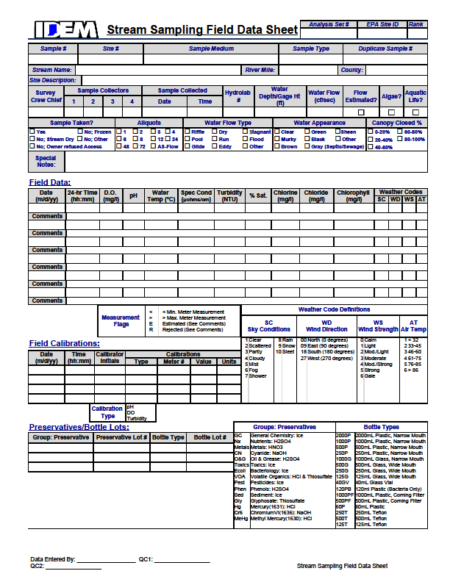Appendix 3 – Stream Sampling Field Data Sheet

Appendix 4 – Fish Collection Data Sheet (Front)



Appendix 4 – Fish Collection Data Sheet (Back)



Appendix 5 – Fish Collection Data Sheet (Example)

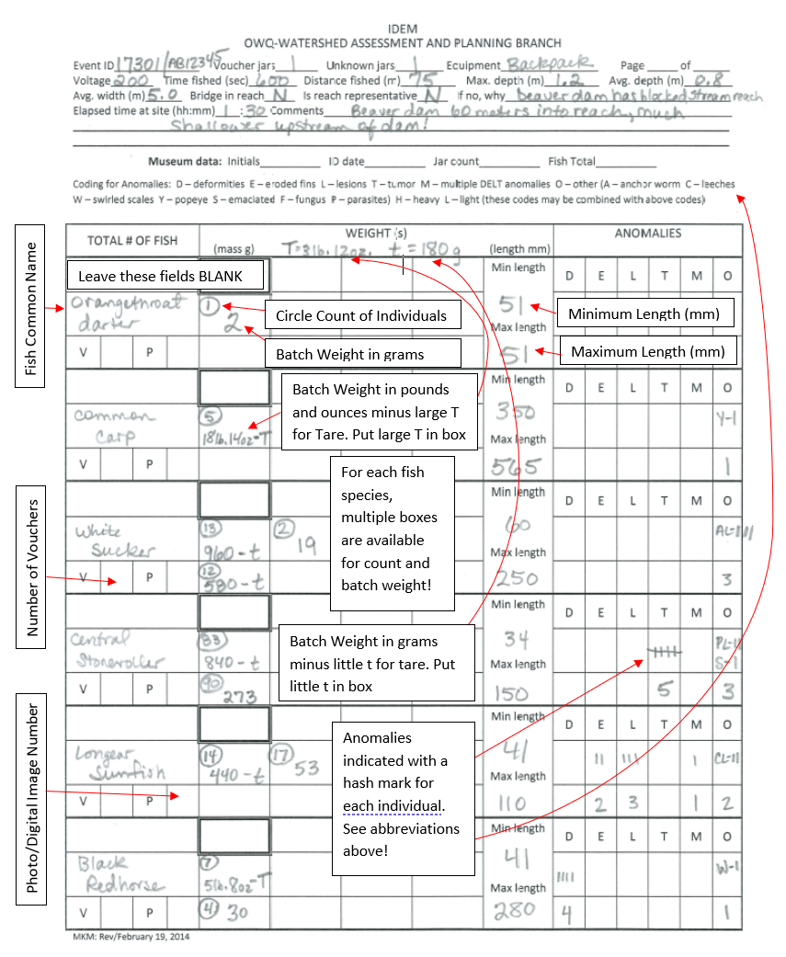

Appendix 6 – OWQ Biological Qualitative Habitat Evaluation Index

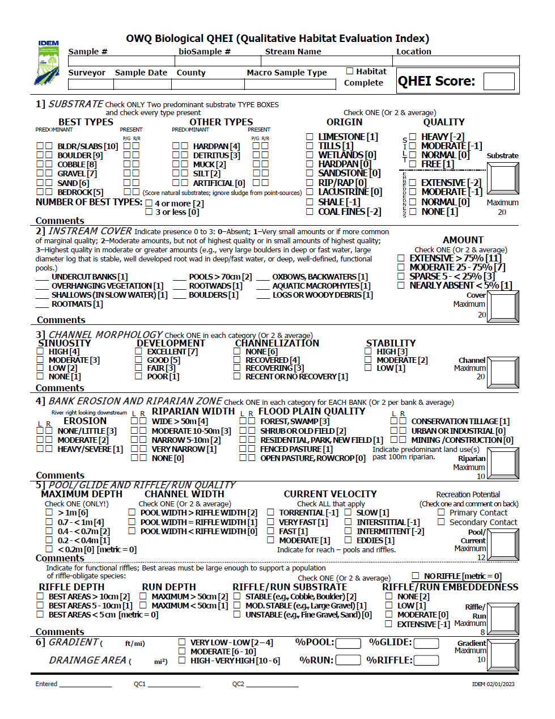

Appendix 6 – OWQ Biological Qualitative Habitat Evaluation Index (back)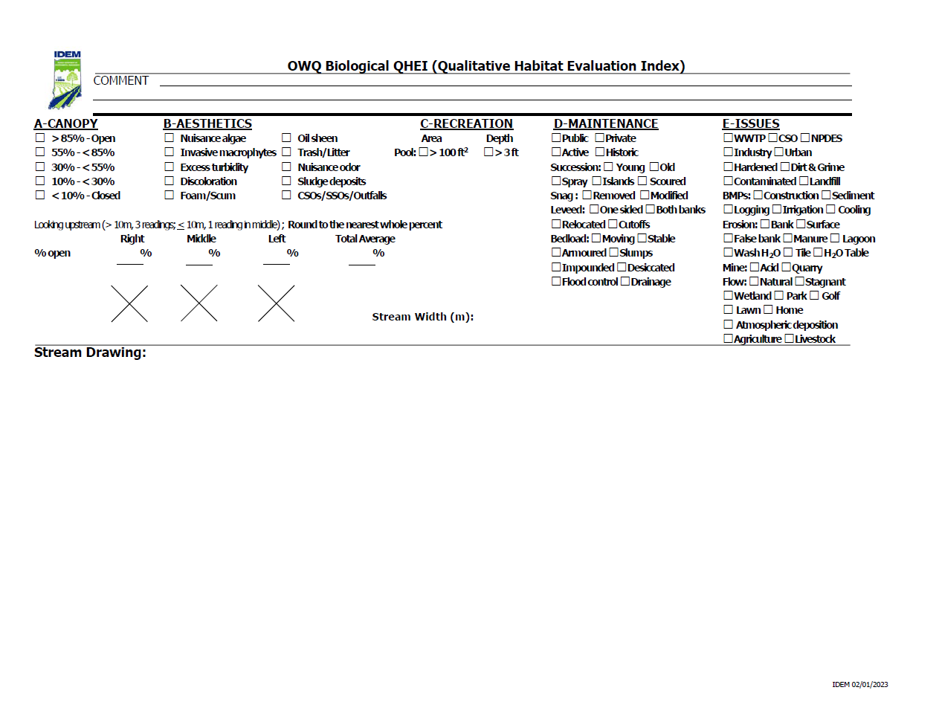

Appendix 7 – OWQ Biological Samples Field Chain of Custody Form

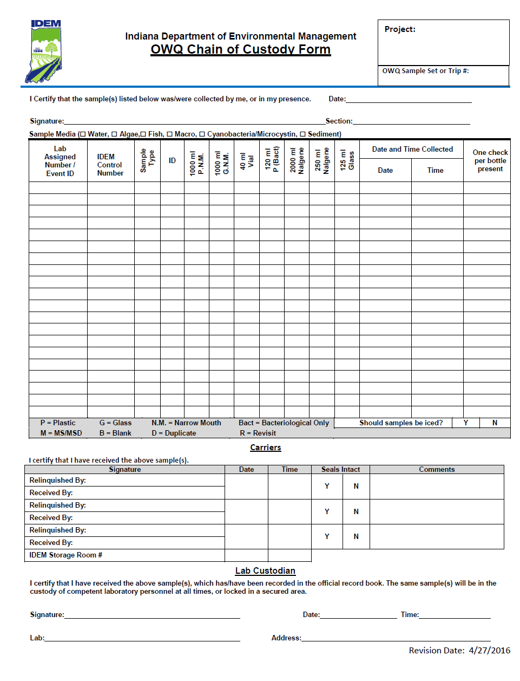

Appendix 8 – Fish Community Sampling Checklist

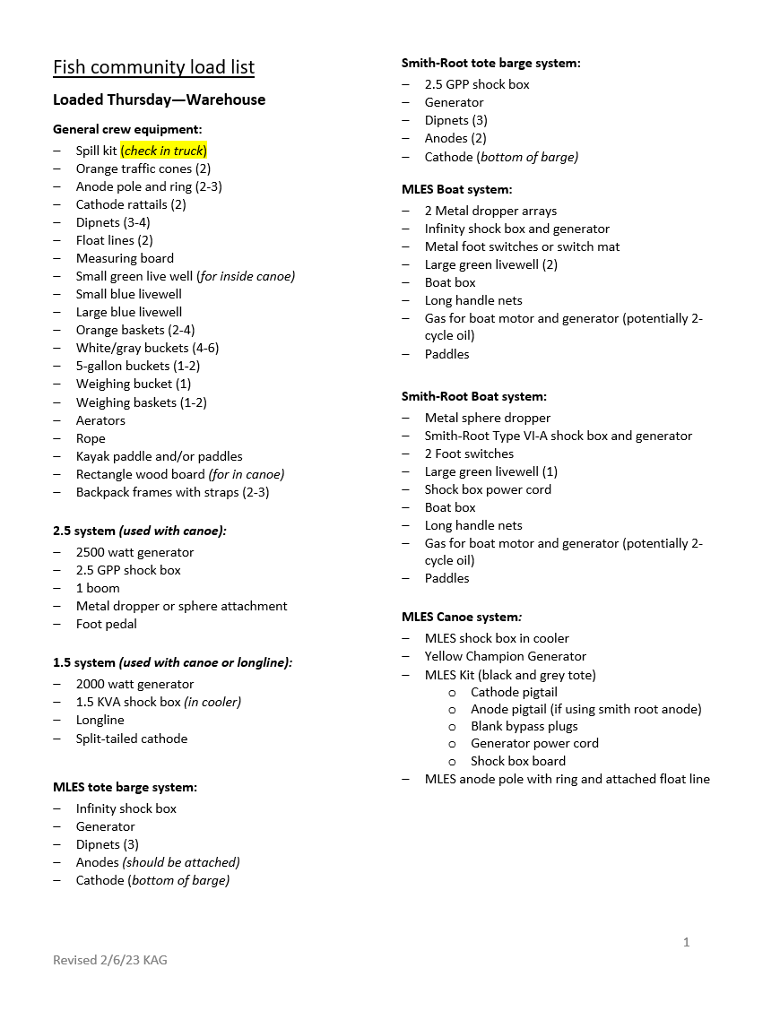

Appendix 8 – Fish Community Sampling Checklist (continued)

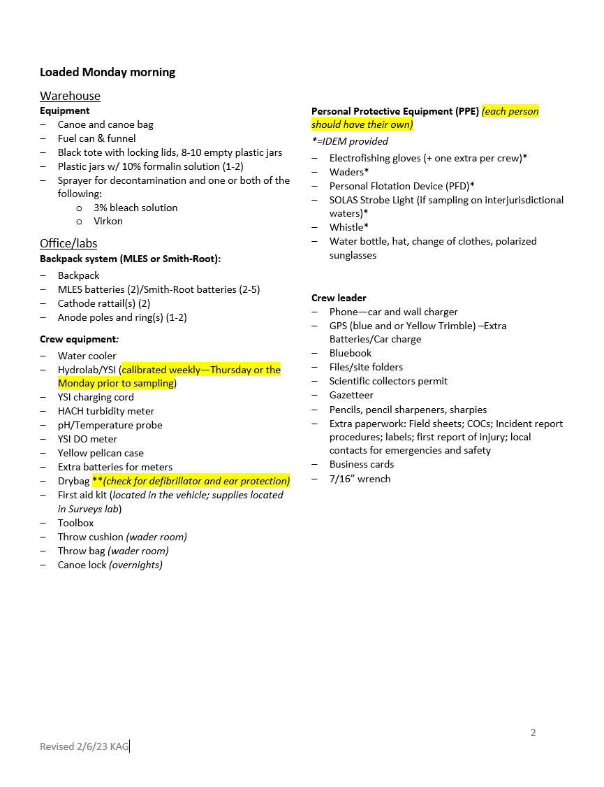

Appendix 8 – Fish Community Sampling Checklist (continued)

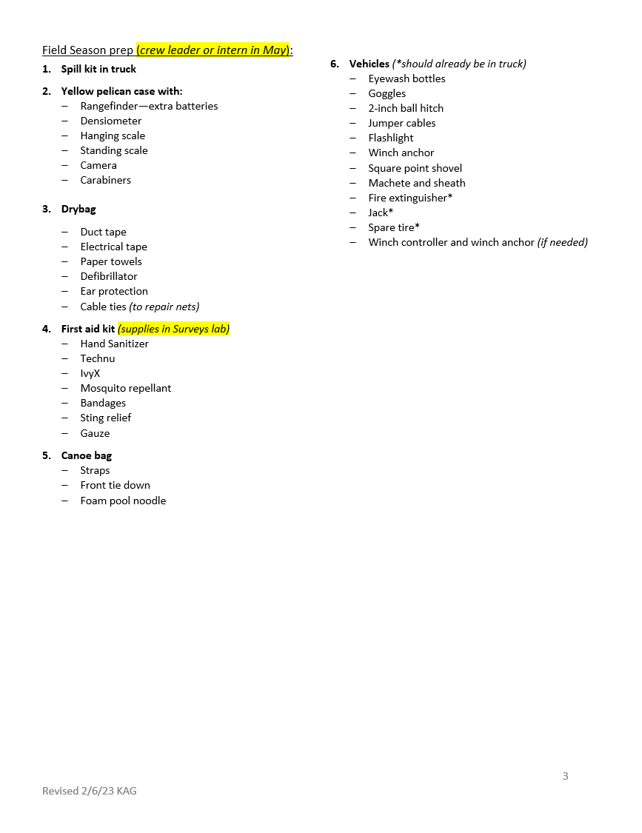

Appendix 9 – Fish Community Sampling Method Characteristics

|  |  |  |  |
| --- | --- | --- | --- |
| **Sampler Type** | | | |
|  | A, B, C | D, E, F | G, H |
| Gear Used: | A: 17’ boat  B: 16’ boat  C: 12’ or 14’ boat | D: Canoe w/ rattail cathode  E: Tote Barge System w/ cathode plate  F: Longline (150m extension cord) | G: Smith-Root Model LR-20B or LR-24 backpack  H: MLES Infinity Xstream backpack |
| Power Source: | A, B: EG 5000 X Honda Generator with a Smith Root type VI-A or MLES Infinity Box (17’ or 16’ boat)  C: Briggs & Stratton 5 HP Generator, Smith Root GPP 2.5 portable electrofisher (RCB-6B Junction Box) in 12’ or 14’ boat | D, E: Honda5 HP Generator with Smith Root GPP 2.5 portable electrofisher (RCB-6B Junction Box), or 3650W Champion Generator with MLES Infinity Box (MLES Junction Box)  F: Honda5 HP Generator, Smith Root GPP 2.5 portable electrofisher (RCB-6B Junction Box) | G: 24V 11.1Ah battery with will run 40 minutes continuous at 100W  H: 24V 19.2Ah battery |
| Current Type: | Pulsed DC | Pulsed DC | Pulsed DC |
| Wattage:  (AC Power Source) | A,B: 5000 (17’ or 16’ boat)  C: 2500 (12’ or 14’ boat) | 2500 (Honda)  3650 (Champion) |  |
| Volts:  (DC Output) | A,B: 0-1020, (suggest 340)  C: 50-1000 (suggest 300) | 50-1000  (suggest 300) | G: 50-990  H: 0-1200  (suggest 100-300) |
| Amperage:  (Output) | A,B: 3-6  C: 5 | 2-4 (Smith Root)  8-12 (MLES) | 2-4 |
| Anode Location: | A,B: Electrosphere on boom or 2 MLES booms with dropper arrays  C: Electrosphere on boom (Large River) or Smith-Root dropper (river with fast current and/or nonwadeable pools) | ring anode, or dropper anode | Smith-Root teardrop, MLES ring anode, or Smith-Root ring anode |
| Number of Netters & Net Mesh Size: | A,B:2 people netting in the front of the boat with 1/8 inch nets  C: 1 person with 1/8 inch net | 2 people netting near anode with 1/8 inch nets | 1-2 people netting near anode with 1/8 inch net |
| Distance Sampled:  (meters) | 15 times the width up to a maximum of 500 m (both banks) | 15 times the width, maximum 500 m minimum 50 m | 15 times the width, maximum 500 m minimum 50 m |
| Sampling Direction: | Downstream and circling around to net fish behind boat (dependent on flow) | Upstream zigzag to collect from all habitats possible | Upstream zigzag to collect from all habitats possible |
| Stream Size: | A,B: large/great rivers  C: Nonwadeable streams | Wadeable streams to headwater tributaries | Headwater tributaries |
| Sampling Period: | Mainstem White River >1000 square miles: Aug.13-Oct.15; mainstem Wabash River sites: Sept.15-Oct. 15;  otherwise: June-Oct. 15;  all daytime electrofishing | June-Oct. 15, daytime | June-Oct.15, daytime |

Appendix 10 – Field Notebook Example

